Lawyers4rights
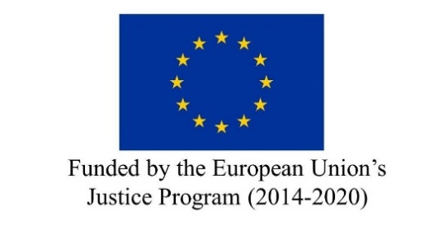

APPLICATION FORM

WEBINAR ON THE CHARTER OF FUNDAMENTAL RIGHTS

3-4 DECEMBER 2020

DATA REQUEST
Surname:
First name:
Country:
- Bulgaria
- Italy
- Spain
Phone number:
Email:
Postal address:
Registered Lawyer:
- Yes
- No
Bar of registration:
Fiscal Code (Italian lawyers only):
Bar Registration Number:

Please select the desired attendance modality:
- Face-to-face attendance (for Italian lawyers only)
- Digital attendance

QUESTIONS TO ANSWER
Do you have any previous knowledge on the EU Charter of Fundamental Rights (CFR)?
- Yes
- No
Are you familiar with the application of the CFR at domestic level?
- Yes
- No
Are you a Human Rights expert or Human Rights lawyer?
- Yes
- No
Do you have any professional experience on Human Rights?
- Yes
- No
Do you have any prior knowledge on fight against terrorism?
- Yes
- No
Do you have any prior knowledge on family reunification?
- Yes
- No
Have you previously participated in any course related to the application of CFR at EU level?
- Yes
- No
If yes, please specify:
Have you published any articles or publications related to terrorism or family reunification?
- Yes
- No
If yes, please specify:
Have you published any articles or publications related to human rights?
- Yes
- No
If yes, please specify:

