Lawyers4rights
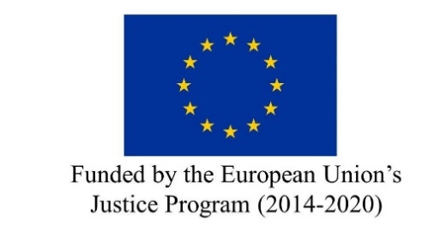

APPLICATION FORM

SEMINAR ON THE APPLICATION OF THE ECFR

BURGOS, 1-2-3 APRIL 2020

DATA REQUEST
Name:
Surname:
Country: Bulgaria Italy Spain
Phone number:
Email:
Registered Lawyer: Yes No
Bar of registration:

QUESTION TO ANSWER
Do you have any previous knowledge on the EU Charter of Fundamental Rights (CFR)?

Are you familiar with the application of the CFR at domestic level?

Are you a Human Rights expert or Human Rights lawyer?

Do you have any professional experience on Human Rights?

Do you have any prior knowledge on fight against terrorism?

Do you have any prior knowledge on family reunification?

Have you previously participated in any course related to the application of CFR at EU level?
If yes, please specify

Have you published any articles or publications related to terrorism or family reunification?
If yes, please specify:

Have you published any articles or publications related to human rights?
If yes, please specify

Supporting documents:
(Mandatory) Curriculum Vitae –EN
(Mandatory) Cover letter –EN
(Optional) - Certificate English

Please tick the box if you would like to have lunch at Residencia Universitaria Camino de Santiago on 2nd April (20€ to be paid in cash at the venue).

